Judicial Academy of the Slovak Republic

Judicial Academy of the Slovak Republic organizes its seminars in the building called „Detached centre of the Judicial Academy of the Slovak Republic“
Detached centre is situated in the natural environment, on the small hill, 25 minutes of walk from the nearby spa city “Trenčianske Teplice”. Address: Omšenie 820
Detached centre is building equipped with 25 double rooms, 3 seminar room for 100 people. Rooms are equipped with the laptops. There is wifi connection in the whole building. Academy uses additional accommodation premises of the nearby Institute of Ministry of Justice in case of full booking of own premises.
There is also canteen that provides everyday meals for the participants of the seminars. Participants may indicate vegetarian diet, lacto-free diet, gluten-free diet.
Bufet provides for all types of coffee, non-alcoholic and alcoholic beverages, snack (sweet and salty) and local speciality – sweet snack called “spa waffles” for purchase.
The building is equipped also with the wellness premises including swimming-pool, whirlpool bath, Jacuzzi, gym, sauna, and massages. The prices amount to from 1 to 10 EUR per procedure.
Photos: http://www.ja-sr.sk/node/80

Connection:
Travel by train from BRATISLAVA:
There are quick trains with the stop “TRENČÍN” or „TRENČIANSKA TEPLÁ“. In case of descending in Trenčín, please continue by BUS information following below.
You can take state trains from company “Železničná spoločnosť Slovensko” or private yellow trains REGIOJET.
In case of descending in TRENČIANSKA TEPLÁ, continue as follows:
Then you have to walk from Train station in Trenčianska Teplá to the Bus station and take the bus direction to Omšenie (or direction Dolná Poruba, which is the village after the Omšenie)
There are two bus stops on the big crossroad.
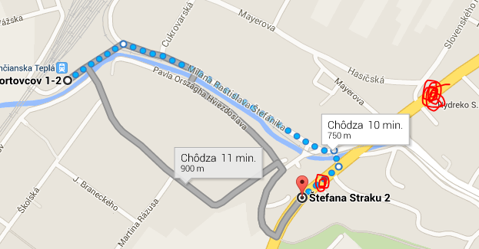

From this first stop, the buses go as follows:
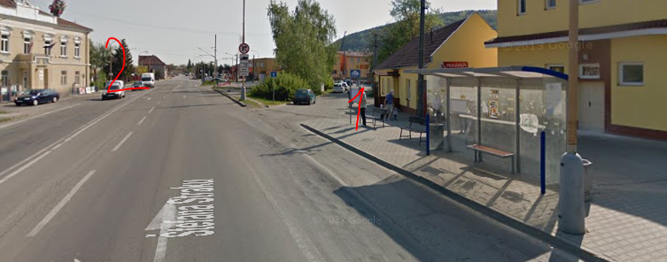
Buses from Trenčianska Teplá – second bus stop to Omšenie
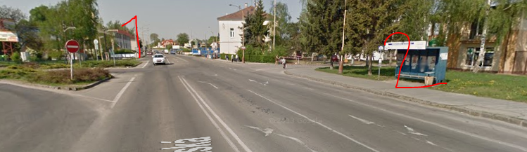
You have to go off the bus in „Trenčianske Teplice,,JAS rekr.str.“
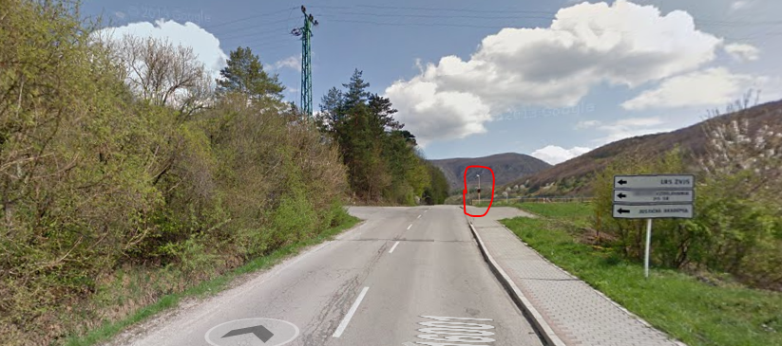

And then walk up this hill: (5-7 minutes)

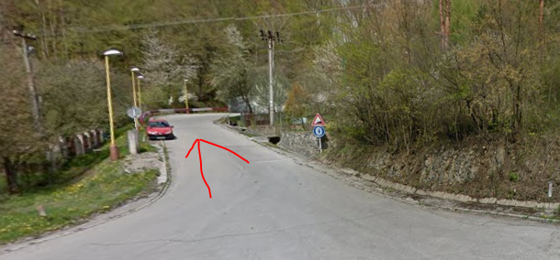
And there you come to the first building on your left, there is the plate with arrow:
Justičná akadémia Slovenskej republiky
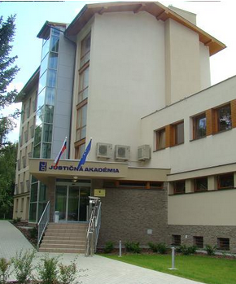

TRAVEL BY BUS FROM BRATISLAVA
You can either take BUS arriving to BRATISLAVA, or international buses going directly to TRENČÍN. The BUSES to BRATISLAVA arrive at MAIN BUS STATION “AS Mlynské Nivy”. Here, just change the platform and take the BUS to TRENČÍN.
ALL busses arrive at the main station in TRENČÍN (there is only one main station in Trenčín)
You will have to swith to the local bus with the direction “Omšenie” or “Dolná Poruba”.
Street view of the station:
https://www.google.com/maps/@48.895812,18.052351,3a,90y,289.17h,89.44t/data=!3m4!1e1!3m2!1sOYBGcVTlEWD3Pc4ykDePlQ!2e0!6m1!1e1

You can easily find the “small platforms” for buses. There are yellow piles with the travel itinerary to Omšenie or Dolná Poruba. Take the bus direction to Omšenie (or direction Dolná Poruba, which is the village after the Omšenie). Then follow the instructions and photos above.
In case of problems with connection from TRENČIN or TRENČIANSKA TEPLÁ, please call to mobile number 00421 911 960 687 and we will try to help you.
In case you are travelling by some international trainis, the INTERNATIONAL TRAIN CONNECTION POINT is “PÚCHOV” or “BRATISLAVA”. In case of arriving to Bratislava, see the instructions above. In case of arriving to PÚCHOV, taky any train going to TRENČIANSKA TEPLÁ (20 minutes) and follow instructions above.

