1. By CAR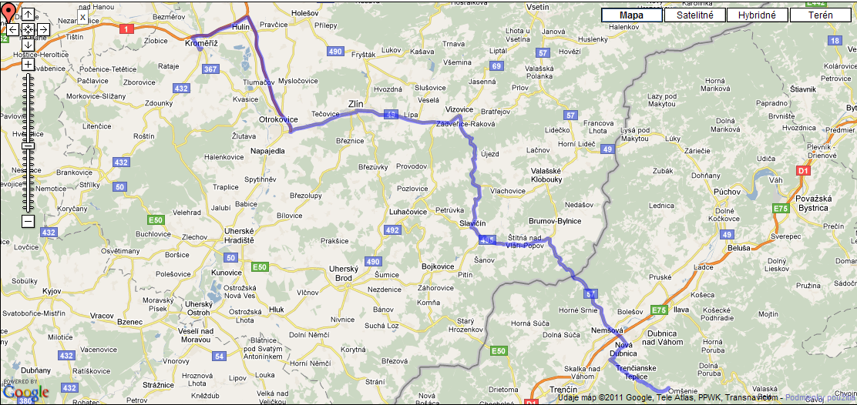
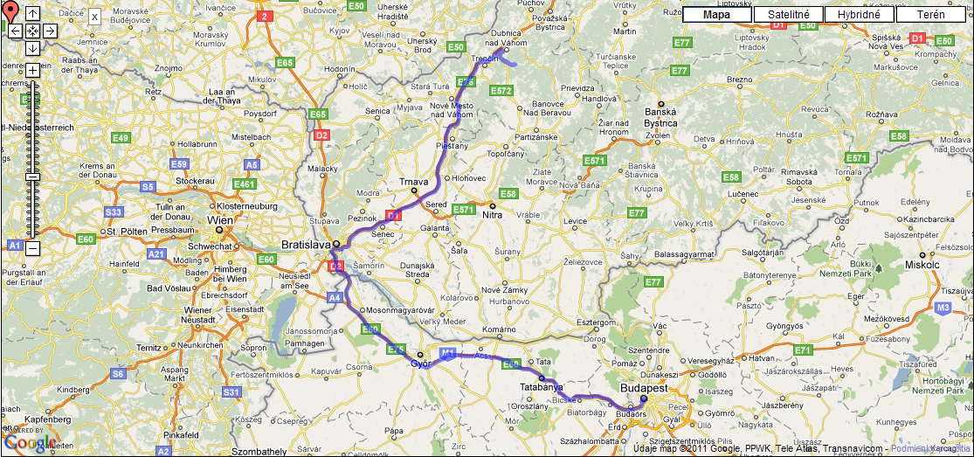
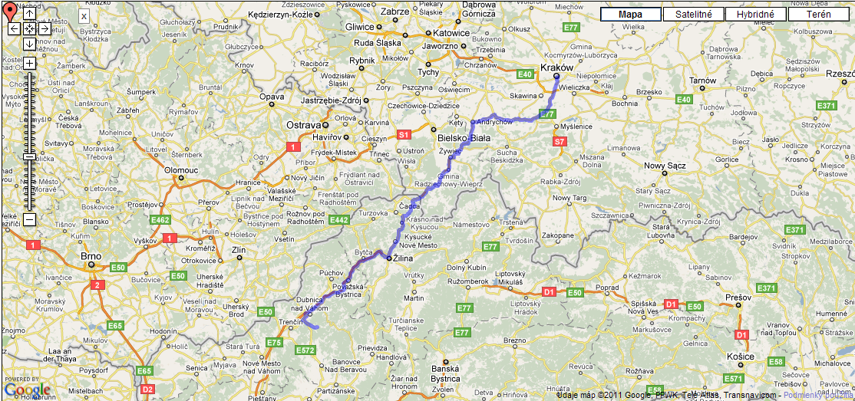
2. By Train –
The nearest Train station is in Trenčianska Teplá, where all the trains, except IC train stop.

Then you have to walk to the bus station and take the bus to Omšenie (or Dolná Poruba, which is the village after the Omšenie) and you have to go off the bus in „Trenčianske Teplice,,JAS rekr.str.“

