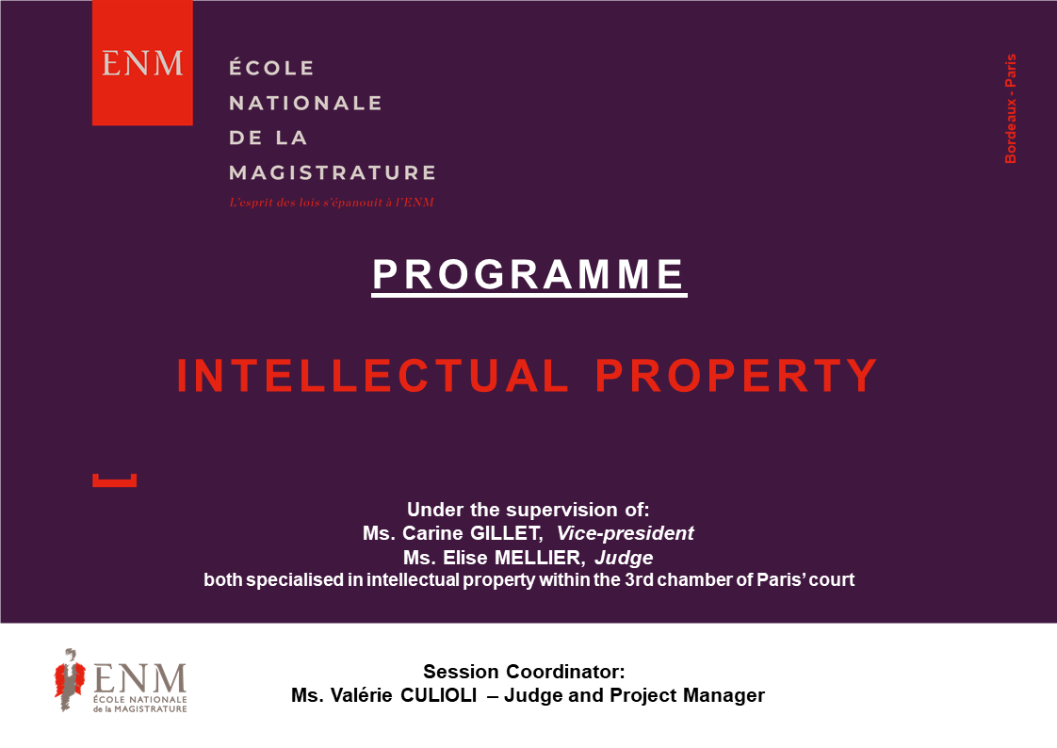

Contact:
Emilie BREYNE - Project Manager – International Department
emilie.breyne@justice.fr / (+33) 01 44 41 88 24

PROGRAMME

Tuesday 06 April 2021 – morning

- Welcome speech - Recommendations for the use of the tool

- Approach to systems relating to intellectual property in France and Europe

Tuesday 06 April 2021 – afternoon

- Copyrights, designs and models

Wednesday 07 April 2021 – morning

- Brands
Wednesday 07 April 2021 – afternoon

- The patent

Thursday 08 April 2021 – morning

- The counterfeiting

Thursday 08 April 2021 – afternoon

- Proof: infringement seizure, official report and report on the internet

Friday 09 April 2021 – morning

- Interim measures: right of information, prohibition measures
Friday 09 April 2021 – afternoon

- Reparation measures

- Closure of the session and review

