Seminar title Event number

Travel cost reimbursement form
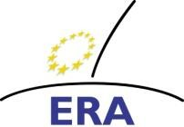
Original receipts only please
Deadline for submission of claim to ERA: 16.01.2022

Better applying European criminal law: legal and language training events for court staff across Europe - Polish National Seminar
321DT15f | Date/Place | 16.- 17.12.2021 - Lublin

First name
Surname
Institution
Address
Postal code
Telephone

 | City |  | Country
 |  |  | Email

ACCOUNT INFORMATION
IBAN
BIC/SWIFT
Bank
Address of the bank
Account holder
Address of the
Account holder

Participation as Speaker

Hotel (max. € 50,00 X 1 night)
Total expenses

Delegate
Amount in €
0

I have incurred the above expenses, and enclose original receipts and tickets. I vouch the for accuracy of this claim.
I have taken note of the information on travel expenses reimbursement on the reverse side.

Place, Date Signature

To be completed by ERA!
ERA Ledger Entry |  | Approved
 | Date
 | Signature

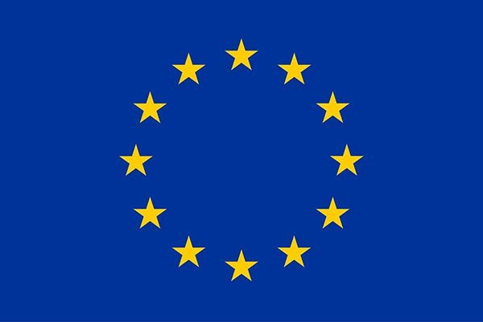
This project is funded by the Justice Programme of the European Union (2014-2020)

Postal address: ERA - Susanne Schuckart - Metzer Allee 4 - 54295 Trier - Germany

