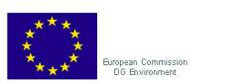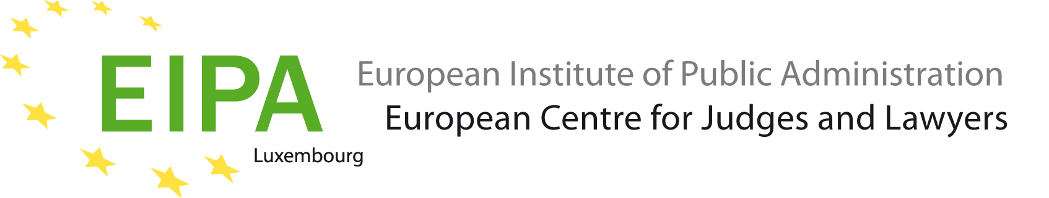

In cooperation with
The Judicial Training Centre of Estonia

Workshop on EU Water Legislation
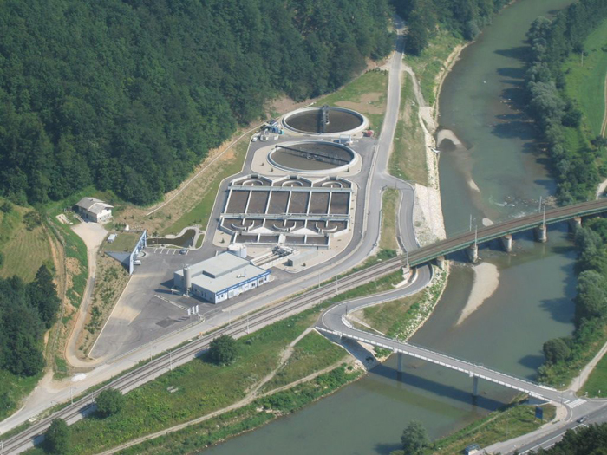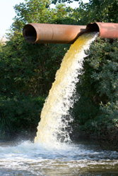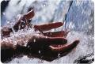
© European Commission, European Environment Agency

programme

Tartu, 5–7 March 2012
Monday, 5 March 2012
9.00 – 9.45 Welcome and Introductory session
Welcome and introduce participants, introduce the facilitators, explain the program and main objectives of the event and give overview on interactive sessions of first day
Igor Dizdarevic (Lecturer, project leader, EIPA), Ralf Jülich (legal expert, activity leader, EIPA)
9.45 – 10.30 EU Environmental Law and National Courts: the Key Role of the National Judge
Introduction into the relevance of EU environmental law for national decisions, and ECJ case procedure initiated by national courts
Igor Dizdarevic
Coffee Break (10.30 – 10.45)
10.45 – 11.30 Case Study I on direct effect
Interpretation of the direct effect of selected water legislation in the EU Member States
Igor Dizdarevic (in plenary)
11.30 – 13.00 Introduction to Water Framework Directive 2000/60/EC
Introductory presentation on the development of European water legislation and key elements of the Water Framework Directive 2000/60/EC
Menno Verheij (EU Commission, Directorate-General for the Environment)
Lunch Break (13.00 – 14.00)
14.00 – 14.45 Directive 91/271/EEC concerning Urban Waste Water treatment
Presentation of the objectives and key aspects of the Urban Waste Water Directive 91/271/EEC
Thomas Ormond (Senior administrator at RP Darmstadt, Department for occupational safety and environment Frankfurt)
14.45 – 15.00 Case Study II – Urban Waste Water
Applying key provisions of the Urban Waste Water Directive Presentation of the facts of the case
Ralf Jülich
Coffee Break (15.00 – 15.15)
15.15 – 17.00 Case Study II continuation
Continuation – Discussion of the case in working groups, presentation of working groups results and debriefing
Ralf Jülich and the participants, largely in working groups
Tuesday, 6 March 2012
9.00 – 9.45 Nitrates Directive 91/676/EEC
Presentation of the objectives and key aspects of the Directive 91/676/EEC concerning the protection of waters against pollution caused by nitrates from agricultural sources
Igor Dizdarevic
9.45 – 10.00 Case Study III - Nitrates and Water Framework Directive
Applying key provisions of the Nitrates Directive and the Water Framework Directive, Presentation of the facts of the case
Menno Verheij
Coffee Break (10.00 – 10.15)
10.15 – 12.15 Case Study III continuation
Continuation – Discussion of the case in working groups, presentation of working groups results and debriefing
Menno Verheij and the participants, largely in working groups
12.15 – 13.00 Bathing Water Directive 2006/7/EC
Presentation of objectives, key aspects and history of the Directive 2006/7/EC concerning the management of bathing water quality
Thomas Ormond
Lunch Break (13.00 – 14.00)
14.00 – 14.45 Drinking Water Directive 98/83/EC
Presentation of objectives, key aspects and history of the Directive 2006/7/EC concerning the quality of water intended for human consumption
Igor Dizdarevic

14.45 – 15.30 Access to environmental information
Presentation of the history, objective and key elements of the Directive 2003/4/EC on public access to environmental information with an additional focus on public consultation under Article 14 Water Framework Directive
Ralf Jülich
Coffee Break (15.30 – 15.45)
15.45 – 17.00 Exchange Session
Exchange of views and experience of participants on water management cases as well as access to environmental information and access to justice
Moderation: Igor Dizdarevic, Ralf Jülich
Wednesday, 7 March 2012
9.00 – 9.45 How to access relevant EU documents on the internet
The use of eurolex and other suitable sources for European environmental legislation, court decisions and other useful documents – a brief guidance
Igor Dizdarevic
Coffee Break (9.45 – 10.00)
10.00 – 10.45 Access to justice
Presentation of requirements of the Aarhus Convention and EU legislation as concerns access to justice and related ECJ jurisprudence
Ralf Jülich
10.45 – 11.30 Evaluation of workshop
Review and feedback of participants on workshop
Moderation: Ralf Jülich

End of workshop, Departure

